**Practical No . 20**

**Aim :** Implementation of mysql-query() in PHP.

**Performed by :** Kartik Mahajan

**Class :** BCA-III SEM-VI

**Date :** 15/03/2025

**Code :**

**connect.php**

<?php

$servername = "localhost";

$username = "root";

$password = "";

$dbname = "my_database";

$conn = new mysqli($servername, $username, $password);

if ($conn->connect_error) {

die("Connection failed: " . $conn->connect_error);

}

echo "Connected successfully";

?>



**form1.php**

<!DOCTYPE html>

<html>

<head>

<title>Insert User Data</title>

</head>

<body>

<form action="insert.php" method="post">

<label for="username">Username:</label>

<input type="text" id="username" name="username" required><br><br>

<label for="email">Email:</label>

<input type="email" id="email" name="email" required><br><br>

<input type="submit" value="Submit">

</form>

</body>

</html>

**insert.php**

<?php

$servername = "localhost";

$username = "root";

$password = "";

$dbname = "my_database";

$conn = new mysqli($servername, $username, $password, $dbname);

if ($conn->connect_error) {

die("Connection failed: " . $conn->connect_error);

}

$user_username = $_POST['username'];

$user_email = $_POST['email'];

$sql = "INSERT INTO user (username, email) VALUES ('$user_username', '$user_email')";

if ($conn->query($sql) === TRUE) {

echo "New record created successfully";

} else {

echo "Error: " . $sql . "<br>" . $conn->error;

}

$conn->close();

?>

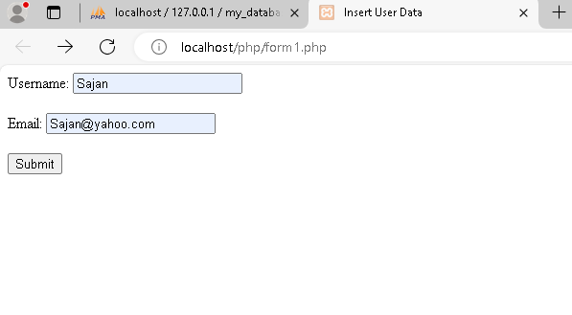

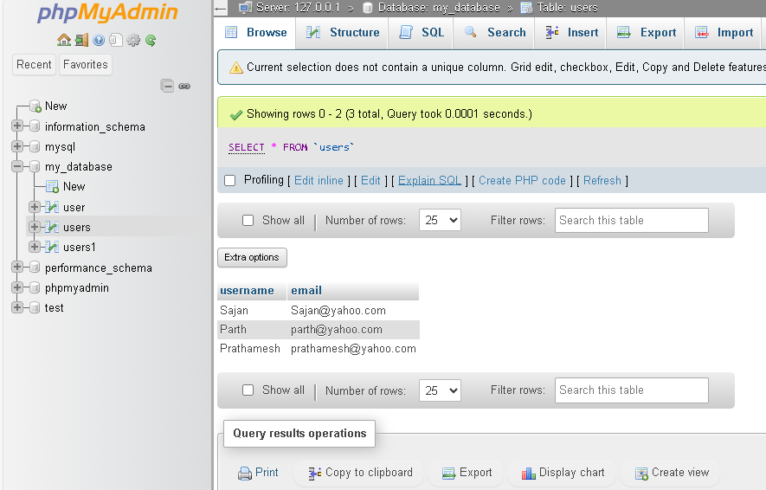

**update_form.html**

<!DOCTYPE html>

<html>

<head>

<title>Update User by Username</title>

</head>

<body>

<form action="update.php" method="post">

<label for="username">Username:</label>

<input type="text" id="username" name="username" required><br><br>

<label for="email">New Email:</label>

<input type="email" id="email" name="email" required><br><br>

<input type="submit" value="Update">

</form>

</body>

</html>

**update.php**

<?php

$servername = "localhost";

$username = "root";

$password = "";

$dbname = "my_database";

$conn = new mysqli($servername, $username, $password, $dbname);

if ($conn->connect_error) {

die("Connection failed: " . $conn->connect_error);

}

$user_username = $_POST['username'];

$new_email = $_POST['email'];

$sql = "UPDATE users SET email='$new_email' WHERE username='$user_username'";

if ($conn->query($sql) === TRUE) {

echo "Record updated successfully";

} else {

echo "Error: " . $sql . "<br>" . $conn->error;

}

$conn->close();

?>

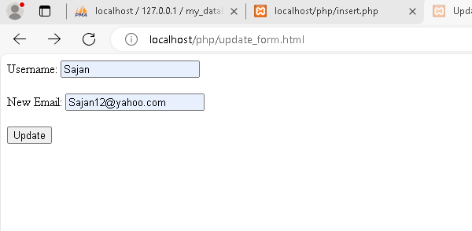



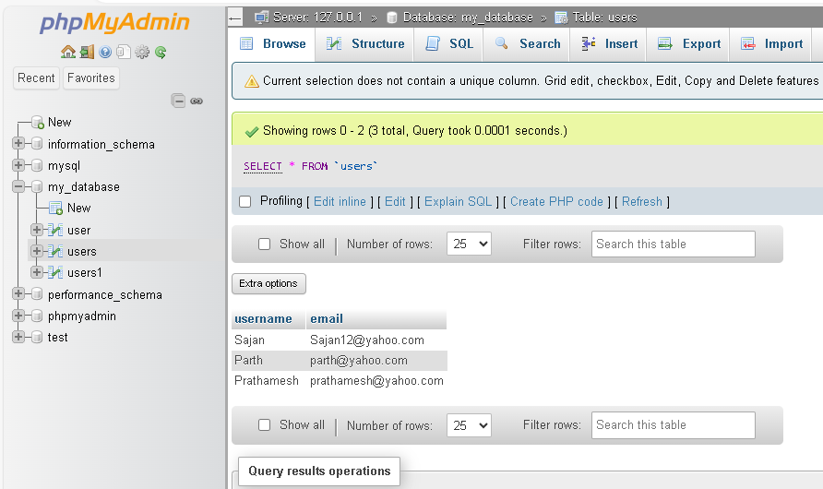

**delete_form.html**

<!DOCTYPE html>

<html>

<head>

<title>Delete User by Email</title>

</head>

<body>

<form action="delete1.php" method="post">

<label for="email">Email:</label>

<input type="email" id="email" name="email" required><br><br>

<input type="submit" value="Delete">

</form>

</body>

</html>

**delete1.php**

<?php

$servername = "localhost";

$username = "root";

$password = "";

$dbname = "my_database";

$conn = new mysqli($servername, $username, $password, $dbname);

if ($conn->connect_error) {

die("Connection failed: " . $conn->connect_error);

}

$user_email = $_POST['email'];

$sql = "DELETE FROM users WHERE email='$user_email' ";

if ($conn->query($sql) === TRUE) {

echo "Record deleted successfully";

} else {

echo "Error: " . $sql . "<br>" . $conn->error;

}

$conn->close();

?>

